APLA Bulletin
Robertson Library - Fall 2016 Update

Staffing
A number of staffing changes have happened at the Robertson Library since the last report to the APLA Bulletin. During the summer we had two retirements. Betty Jeffery, Instruction and Reference Services Librarian and former President of the UPEI Faculty Association, retired on July 1st. Library Technician Joy MacLaine retired at the end of August after almost 40 years of service. In July we also said goodbye to term Librarian Lindsey MacCallum as she took on a new position at Mount Saint Vincent University. The Library has hired a new term Librarian and recent graduate from Dalhousie’s School of Information Management program, Mark Cousins. We have recently advertised and filled a new Public Services and Digital Projects Library Technician position and will welcome the new employee in October.

Research
Librarian Melissa Belvadi was successful in her application for a UPEI Internal Research Grant - Validating a Myth: Do Books that Fail to Circulate in Their First 10 Years Ever Do So? and is studying whether books acquired by the library in the early 1990s that didn’t circulate within their first 5-10 years have ever circulated since. She is currently analyzing the results of her study.

Digital Collections

As part of the The L.M. Montgomery Institute's 12th Biennial Conference, the Library launched a new digital collection: KindredSpaces. KindredSpaces is an online discovery tool for the LM Montgomery Research Collections housed at the UPEI Robertson Library. KindredSpaces launches with a digitized collection of periodicals featuring Montgomery’s poems and short stories. The periodicals are part of the Ryrie-Campbell collection, donated by Dr. Donna Jane Campbell, which includes archival material, artifacts, and a large selection of rare and interesting books by and about Montgomery
See: http://kindredspaces.ca
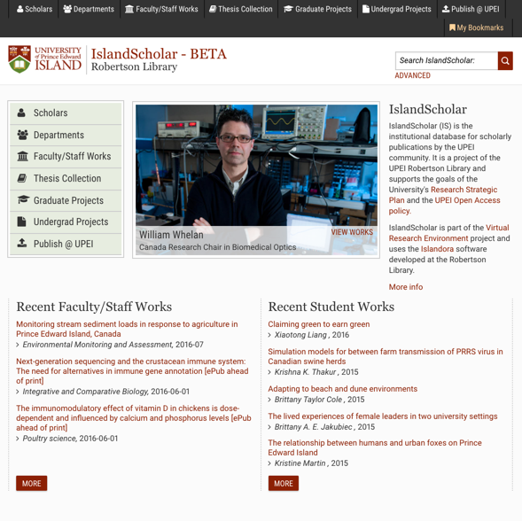
IslandScholar
Since the Fall of 2015, Library staff have been working on an upgrade and redesign of IslandScholar, our Islandora-based institutional repository. Content includes bibliographic records for scholarly output and includes full text where permitted, graduate theses and projects, and undergraduate projects and honours theses. Features include faculty profiles, integration of Altmetrics and view/download statistics, faceted search, embargos, and more. We plan to launch the new site on July 4th.

data.upei.ca
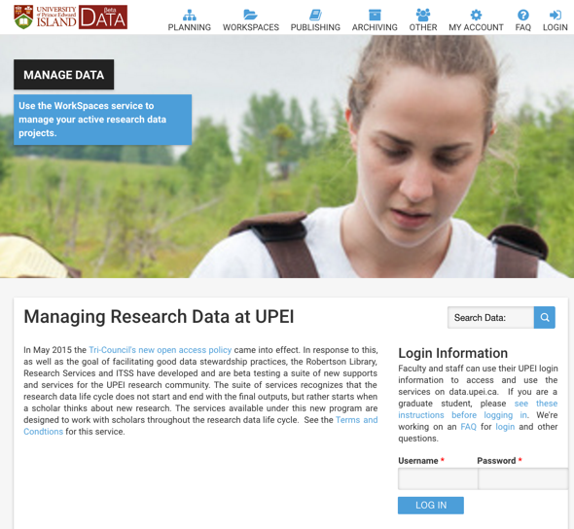

A yet to be branded Research Data Management service, data.upei.ca, is currently running as a pilot. data.upei.ca is intended as a “one stop shop” and provides a comprehensive set of services including a data management planning tool, an integration with Pydio for a local file store, integration with Islandora to provide longterm preservation of datasets and publication/sharing of datasets where permissable. Datasets can also be linked to their related publications. For more information contact Dawn Hooper (dhooper@upei.ca). See: https://data.upei.ca

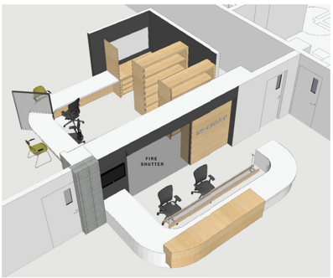
Single Service Desk

To help improve our service to clients, the Robertson Library consolidated its multiple service points (Circulation, Information/Reference, and IT) into a single service desk. Renovations were completed during the Summer months and the new desk was ready for New Student Orientation day. The space that the old Circulation Desk occupied is currently getting some attention.

Virtual Reference
The Library is trying a new approach to staffing virtual reference this fall. During week days, staff are asked to log on when they are available at their desks. There is no set schedule and evening and weekend coverage is provided by staff at the Service Desk. We also have a separate queue for staff working on the Service Desk to request additional support from colleagues should they need it on the Desk itself.

New Student Orientation
UPEI revised its New Student Orientation program this year and the Robertson Library was a featured stop and we welcomed over 400 new students.

